
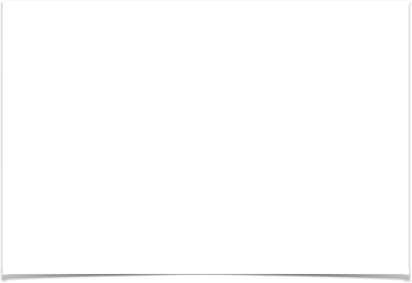

Analysis & Design Project 2018

Table of Contents
Contents

Analysis & Design Project 2018 1

Table of Contents 2

Student Declaration 4

Part A 5

A Glossary of Terms .6

Assumptions 7

1. Create a Domain Model for Oak Vally. 8

2. Create system sequence diagrams to model the following features 9
i. Find the total cost of an order for a particular customer………...9
ii. Find the current location of a driver who is out on a delivery…...9
iii. Find the delivery address of an order……………………………10
iv. Find the status of an order………………………………………..10
v. Find the journey time for a particular delivery schedule……….11

3. Identify operations signatures required to complete each feature. Assign each operation to appropriate class. 11

4. Create sequence diagrams to realize the happy scenario for each of the above features. 12-14

5. Create a Design Class Diagrams to support the sequence diagrams created in 3. Your design class diagram should contain at least one controller class 15

6. Extend design Class Diagram to allow for the following additional requirement. 16
i. A customer would like to return a damaged product.

7. Explain how the design class diagram would be mapped to Java. 17

Part B 18

Q1 Explain the meaning of the MVC pattern using the following sample code. 18

Q2 Explain the meaning of the Observer Design Pattern using the following code ……… 19

Q3 Explain the meaning of the facade design pattern using the following code 20

Student Declaration

I can confirm the following details:

Student ID/Registration Number : R00144214
Name : Mohammed Alom

Module Name: OO Analysis and Design
Module Lecturer: Ms Deirdre Dunlea

I confirm that this is my own work.
Due Date: Wednesday 9th May 2018

Student Signature:

Signed: Mohammed Jahangir Alom
___________________

Part A

Glossary of Terms

- Oak Valley Furniture - a location, the main head office.
- Store Room – a location where business is conducted, and product kept. Oak Valley has many stores.
- Region – a location, store is divided by region each region has driver.
- Vehicle – Oak valley has vehicles.
- Schedule – vehicle has schedule.
- GPS – vehicle has GPS and driver use GPS to get address and find out journey time.
- Delivery – driver transport order to the customers.
- Customer - a person who buys goods or services from a shop or business.
- Order Status - is it delivered or returned or currently processing for delivery.
- Product Line - a complete list of items, typically one in alphabetical or other systematic order, in particular:
- Payment - the action or process of paying someone or something or of being paid.
- Sales Person - a person employed for wages or salary, especially at non-executive level.
- Vendor – a person or company who supplied products to the shop or business.
- Stock- where product kept.
- Warehouse – Oak valley store excess product to the warehouse.
- Commission – sales person receive commission based on sales or particular store.

Assumptions

- Company (assumption: reservation can be done by phone and online)
- Customer will get refund or replace if they returned product due to damage.
- Customer will register their details before order.
- Money will be refund if they cancel their order within 24 hours.
- Customer will provide their mobile number to receive expected delivery time and date.

Other assumptions are stated during the document.

1. Create a Domain Model for Oak Valley.
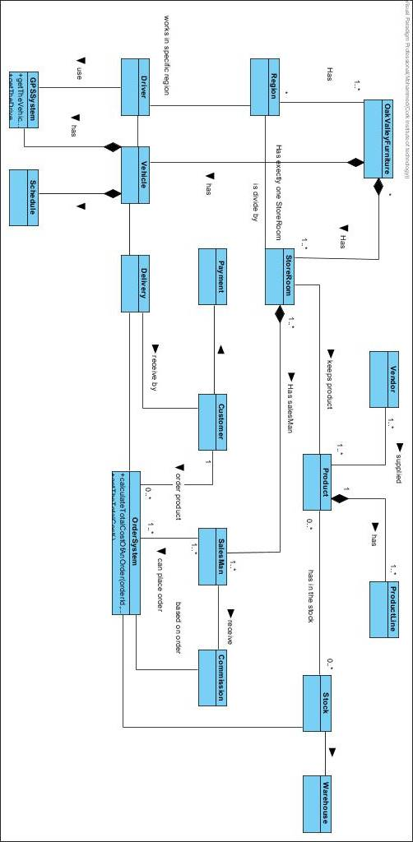
2. Create system sequence diagrams to model the following features

Find the total cost of an order for a Customer - SSD

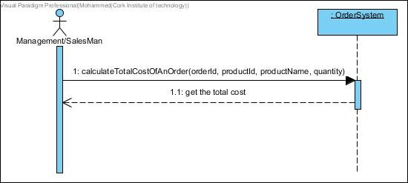

Find the current location of a driver who is out on a delivery-SSD

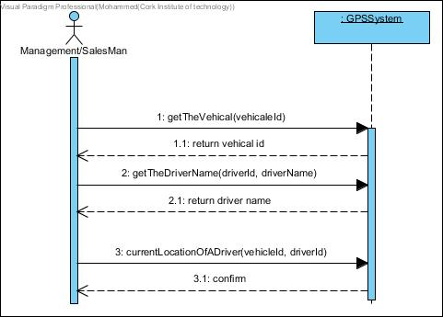

Find the delivery address of an order -SSD

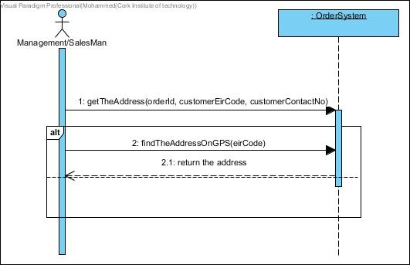

Find the status of an order -SSD

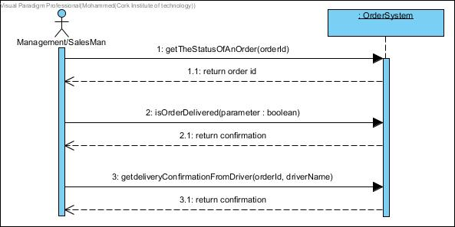

Find the journey time for a particular delivery schedule -SSD

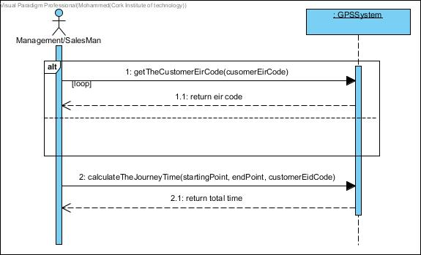

3. Identify operations signatures required to complete each feature. Assign each operation to appropriate class.

All the operations have been used in the system sequence diagram to complete the different task.
As well as all the operation has been added to the class diagram.

4.Create sequence diagrams to realize the happy scenario for each of the above features.

Find the total cost of an order for a particular customer- Happy Scenario

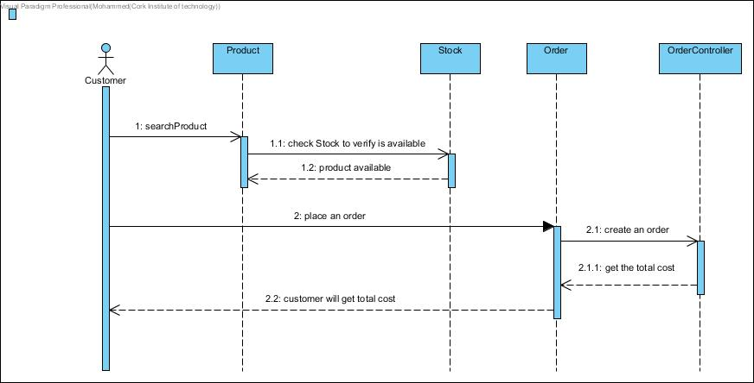

Find the current location of a driver who is out on a delivery- Happy Scenario

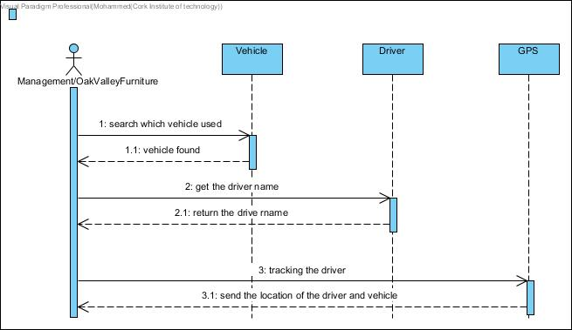

Find the delivery address of an order- Happy Scenario

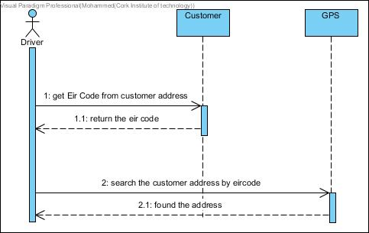

Find the status of an order- Happy Scenario.

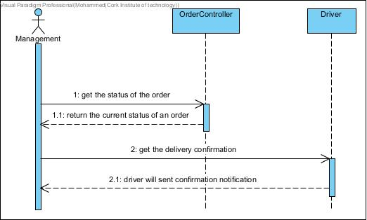

Find the journey time for a particular delivery schedule -Happy Scenario

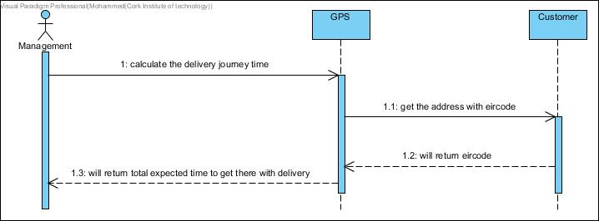

- Create a Design Class Diagram to support the sequence diagrams created in 3. Your design class diagram should contain at least one controller class.

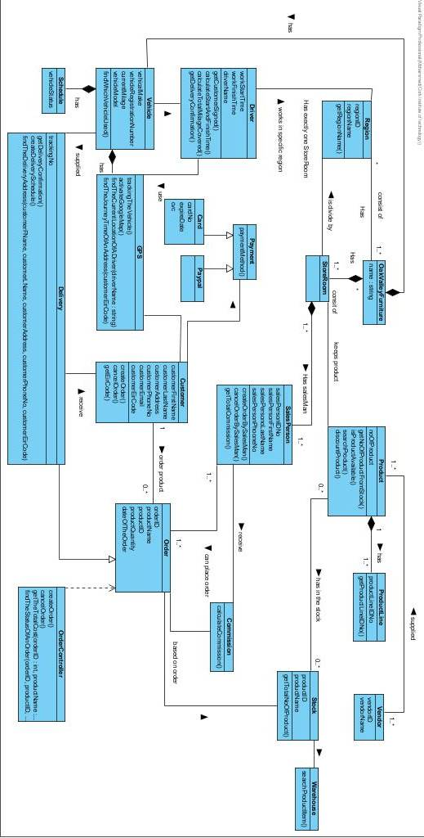
6.Extend design Class Diagram to allow for the following additional requirement.
A customer would like to return a damaged product.
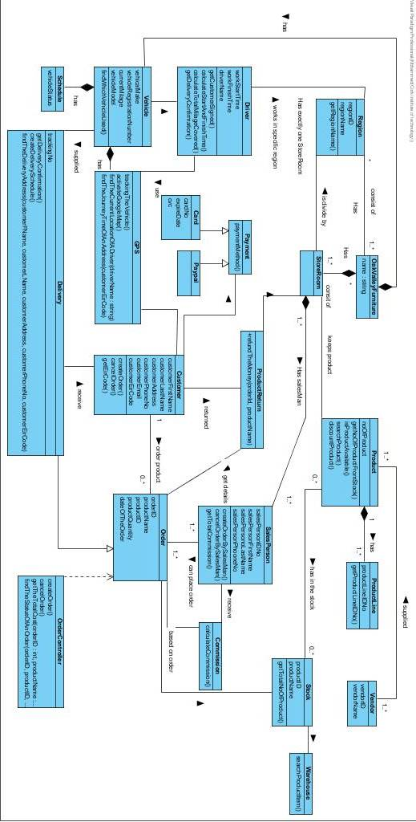
7. Explain how the design class diagram would be mapped to Java.

With this class diagram can be represented in a Java Program by converting each class into a java code. You identify the class by putting the classes names into java code and the attributes and operations from the class become active.

Links between classes need to be mapped using association, aggregation, composition and inheritance.

Four different types of transformations to java

- Model transformation
Optimizing the object design model

- Forward engineering
Implementing the object design model in a programming language
Mapping inheritance
Mapping associations
Mapping contracts to exceptions
Mapping object models to tables

- Reverse engineering

- Refactoring

Part B

1. Explain the meaning of the Observer Design Pattern using the following code.

The object which is being watched is called the subject. The objects which are watching the state changes are called observers or listeners.

The use of the Observer Design Pattern is the following

Specify a one-to-many dependency between objects so that when one object changes state, all its dependents are given notice and updated automatically.

The "View" part of Model-View-Controller.

The problem:
The problem with the Observer Design Pattern is a large design does not scale easily as new graphing or monitoring requirements are imposed.

Class Diagram:
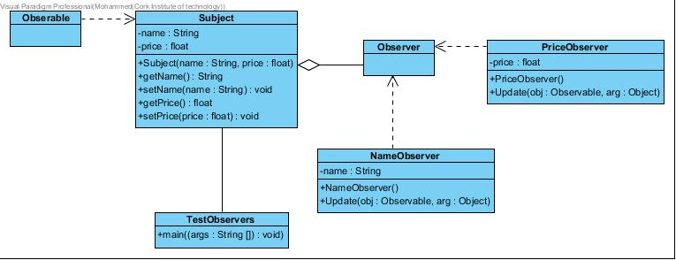

2. Explain the meaning of the MVC pattern using the following sample code.

What it does is put up a black circle that gradually turns red, then the program stops.

The Model does the work. Whenever it does something that another class might be interested in, it "broadcasts" the fact to all other classes that might be needed to know. The Model does not need to know or care anything about which other classes, if any, might be interested, so it remains completely independent of those classes.

The Controller in this program doesn't actually have any controls. It does set up the GUI, creates the Model and the View, and register the View as an observer of the Model.

Class Diagram:

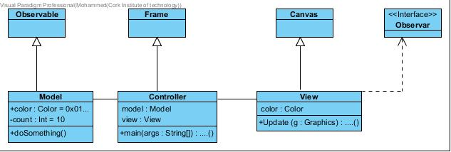

- Explain the meaning of the facade design pattern using the following code

The Facade design pattern simplifies the interface to a complex system. it is usually composed of all the classes which make up the subsystems.

A Facade shields the user from the complex details of the system and provides them with a simplified view of it which is easy to use. It also decouples the code that uses the system from the details of the subsystems, making it easier to modify it later.

What the programmed does is it looks over and get the CPU power, memory and hard drive information.

Class Diagram:

